**SHIMONI DEMONSTRATION SCHOOL- KIRA**

**MID TERM TW0 EXAMINATIONS, 2023**

**TOP CLASS HEALTH HABITS**

**Name ____________________________________________________**

1. Name these parts of the body.

|  |  |  |
| --- | --- | --- |
|  |  |  |
|  |  |  |
|  |  |  |
|  |  |  |

**(head, mouth, ears, nose, eyes, leg)**

1. Read sentences and draw.

|  |  |  |
| --- | --- | --- |
| These are my eyes | I have one nose | These are my ears |
|  |  |  |

1. Fill in the missing letters.

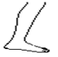l___g 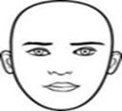 h___ad

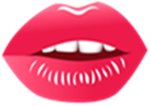m____uth 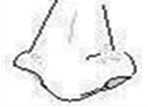n____se

1. Make sentences.

This is my leg.

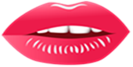____________________________

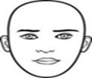________________________________

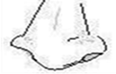_______________________________

1. Match correctly.

eye feeling

ears seeing

nose tasting

tongue smelling

skin hearing

1. Read and draw

|  |  |  |
| --- | --- | --- |
| tooth brush | Soap | Comb |
|  |  |  |

1. Fill in the missing letters.

C_____mb t____ ____th brush

t____wel S____ap Sp_____nge.

1. Complete correctly.

That is my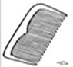 ________________

I have two ________________

That is a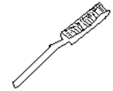 ________________

1. Complete correctly.

I use my eyes for _____________________

I use my ears for ______________________

I use my nose for ______________________

I use my tongue for ____________________

I use my skin for ______________________

**(hearing, smelling, tasting, feeling, seeing)**

**END**